**Safety Gloves**

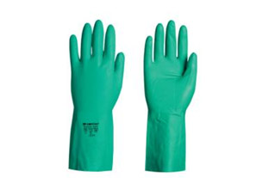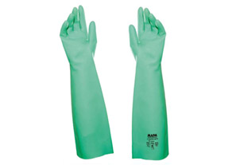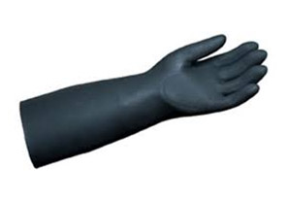

### Nitrile Gloves 14'' Nitrile Gloves 18'' Neoprene Gloves

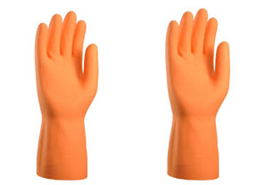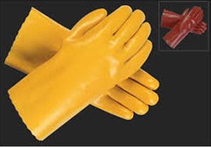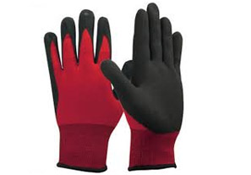

### Acid Alkali Gloves PVC Double Dipped Latex Palm Coated

### http://capricornsafety.co.in/images/safety-gloves/7.jpghttp://capricornsafety.co.in/images/safety-gloves/8.jpghttp://capricornsafety.co.in/images/safety-gloves/9.jpg

### Nitrile palm Coated Leather Gloves Heat resistant Gloves

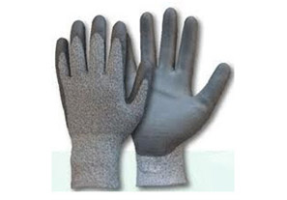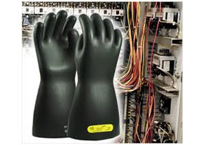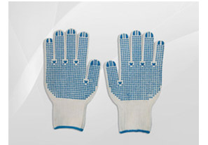

### Cut Resistant Gloves Electrical Gloves PVC Coated Gloves

### http://capricornsafety.co.in/images/safety-gloves/13.jpg

### Surgical Gloves